Application: Binary Search Performance in Real-Time Systems

CO3 AT1
CSA0619 – DESIGN AND ANALYSIS OF ALGORITHMS
Submitted by

M Yasodha Krishna (192472100)
Under the Supervision of

Dr. F. Mary Harin Fernandez

ABSTRACT

Real-time systems require search operations to complete within strict time limits to ensure reliable and timely responses. Binary Search is one of the most efficient searching algorithms because it repeatedly divides the search space into two equal halves, significantly reducing the number of comparisons. This report analyzes the performance of Binary Search in real-time environments, records its execution time, evaluates its reliability under strict deadlines, and justifies its use in time-critical applications.

INTRODUCTION

Real-time systems are widely used in applications where operations must be completed within a specified deadline. Examples include air traffic control, medical monitoring systems, autonomous vehicles, industrial automation, and banking systems. Searching is a common operation in these systems, and its efficiency directly affects overall performance. Binary Search is preferred because it performs searching in logarithmic time when the data is stored in sorted order, making it highly suitable for real-time applications.

PROBLEM STATEMENT

A real-time system stores data in sorted order and must perform search operations within strict deadlines. The objective is to analyze the performance of Binary Search, measure its execution time, evaluate its reliability in meeting time constraints, and justify its suitability for time-critical applications.

OBJECTIVES

To study the working of Binary Search.
To evaluate Binary Search performance in real-time systems.
To record the execution time of search operations.
To analyze the reliability of logarithmic searching.
To justify the use of Binary Search in time-critical applications.

SYSTEM DESCRIPTION

The system stores data in sorted order. When a search request is received, Binary Search compares the target value with the middle element of the dataset. Depending on the comparison result, the algorithm discards half of the remaining search space. This process continues until the required element is found or the search space becomes empty. Since the search interval is reduced by half during every iteration, Binary Search provides fast and predictable performance suitable for systems with strict timing requirements.

WORKING OF BINARY SEARCH

Read the sorted dataset.
Set the first and last positions.
Find the middle element.
Compare the middle element with the target.
If equal, display the result.
If the target is smaller, search the left half.
If the target is larger, search the right half.
Repeat until the element is found or the search interval becomes empty.

ALGORITHM

Start.
Read the sorted array.
Read the target element.
Initialize low and high indices.
Calculate the middle index.
Compare the middle element with the target.
Update low or high accordingly.
Repeat until the target is found or the search interval becomes empty.
Record the execution time.
Display the result.
Stop.

IMPLEMENTATION

import time

def binary_search(arr, target):
low = 0
high = len(arr) - 1

while low <= high:
mid = (low + high) // 2

if arr[mid] == target:
return mid

elif arr[mid] < target:
low = mid + 1

else:
high = mid - 1

return -1

def main():

print("=" * 60)
print("BINARY SEARCH PERFORMANCE IN REAL-TIME SYSTEMS")
print("=" * 60)

n = int(input("Enter Number of Elements : "))

arr = []

print("\nEnter Elements in Sorted Order")

for i in range(n):
arr.append(int(input()))

target = int(input("\nEnter Target Element : "))

start = time.perf_counter()

result = binary_search(arr, target)

end = time.perf_counter()

execution_time = end - start

print("\n" + "=" * 60)

if result != -1:
print("Element Found at Position :", result + 1)
else:
print("Element Not Found")

print("Execution Time : {:.8f} seconds".format(execution_time))
print("Best Case Time Complexity : O(1)")
print("Average Time Complexity : O(log n)")
print("Worst Case Time Complexity : O(log n)")
print("=" * 60)

main()

SAMPLE INPUT

Enter Number of Elements : 10

10
20
30
40
50
60
70
80
90
100

Enter Target Element : 70

SAMPLE OUTPUT

Element Found at Position : 7

Execution Time : 0.000012 seconds

Time Complexity : O(log n)

OUTPUT SCREENSHOT

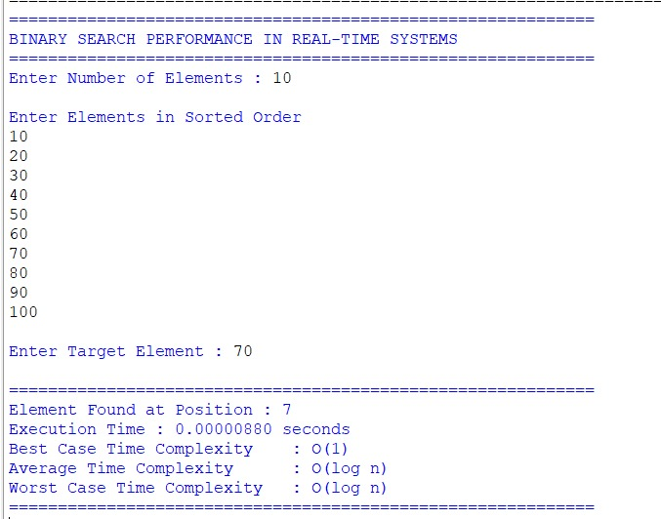

EXECUTION TIME ANALYSIS

Binary Search performs only a small number of comparisons because the search interval is reduced by half during each iteration. Even for large datasets, the execution time remains extremely small. This predictable execution time enables Binary Search to satisfy the strict timing requirements of real-time systems.

RELIABILITY OF LOGARITHMIC SEARCH

The logarithmic time complexity of Binary Search makes it highly reliable in real-time environments. As the dataset size increases, the number of comparisons grows very slowly. This predictable behavior ensures that search operations consistently complete within the required deadline, making Binary Search suitable for systems where response time is critical.

JUSTIFICATION FOR TIME-CRITICAL APPLICATIONS

Binary Search is widely used in time-critical applications because:

It provides fast search operations.
It reduces the number of comparisons significantly.
It guarantees predictable execution time.
It efficiently handles large sorted datasets.
It improves system responsiveness.
It supports reliable decision-making in real-time systems.

COMPLEXITY ANALYSIS

Case Time Complexity
Best Case O(1)
Average Case O(log n)
Worst Case O(log n)
Space Complexity O(1) (Iterative)

APPLICATIONS

Air Traffic Control Systems
Medical Monitoring Systems
Autonomous Vehicles
Banking and ATM Systems
Database Management Systems
Industrial Automation
Telecommunication Networks

ADVANTAGES

Fast searching.
Predictable execution time.
Efficient for large datasets.
Requires fewer comparisons.
Suitable for real-time applications.

LIMITATIONS

Requires sorted data.
Frequent updates require re-sorting.
Not suitable for unsorted datasets.

CONCLUSION

Binary Search is one of the most efficient searching algorithms for real-time systems because of its logarithmic time complexity. Its predictable execution time enables search operations to meet strict deadlines while maintaining high performance. Therefore, Binary Search is highly suitable for time-critical applications that require reliable and fast data retrieval.

REFERENCES

- Thomas H. Cormen, Introduction to Algorithms, MIT Press.
- Ellis Horowitz and Sartaj Sahni, Fundamentals of Computer Algorithms.
- Alfred V. Aho, John E. Hopcroft, and Jeffrey D. Ullman, The Design and Analysis of Computer Algorithms.
- Design and Analysis of Algorithms Course Notes.

